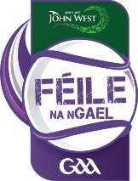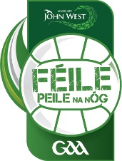

Maidir Le: John West Féile na nGael/Féile Peile na nÓg Skills Star Challenge

A chara,
As Chair of the National Féile Committee I would like to invite you to nominate one player to represent your County at the John West Féile na nGael/Féile Peile na nÓg Skills Star Challenge. I ask that you organise a competition internally in your County in order to identify the representatives. I have enclosed a copy of the organisation for each of the Hurling/Camogie and Boys/Girls Football challenge.

The National Skills Star Challenge will take place on Saturday, June 11th in the National Games Development Centre in Abbotstown, Dublin. The competition will commence at 11am and conclude at 4pm.

I have also enclosed the nomination form for each County. Please complete and return this form to the address identified once you have completed your competition. Please note that the closing date for receipt of applications if Monday, May 9th 2016.

If you have any queries, please do not hesitate to contact Peter Horgan using the details below.

Is mise,

Mairtín Ó Scealaí
Cathaoirleach, An Choiste Fhéilte

For correspondence, please contact:
Peter Horgan
Email: secretary.nationalféile@gaa.ie
Guthán 1/ Tel 1: +353 (0) 1 836 3222
Guthán 2/ Tel 2: +353 (0) 1 865 8625
Faics / Fax: +353 (0) 1 865 8650

GAA, Páirc an Chrócaigh, Baile Átha Cliath 3 / GAA, Croke Park, Dublin 3

